1.Write a Java program to print 'Hello' on screen and then print your name on a separate line.   
Expected Output :  
Hello  
Alexandra Abramov

Ans. public class Exercise1 {

public static void main(String[] args) {

System.out.println("Hello\nAlexandra Abramov!");

}

}

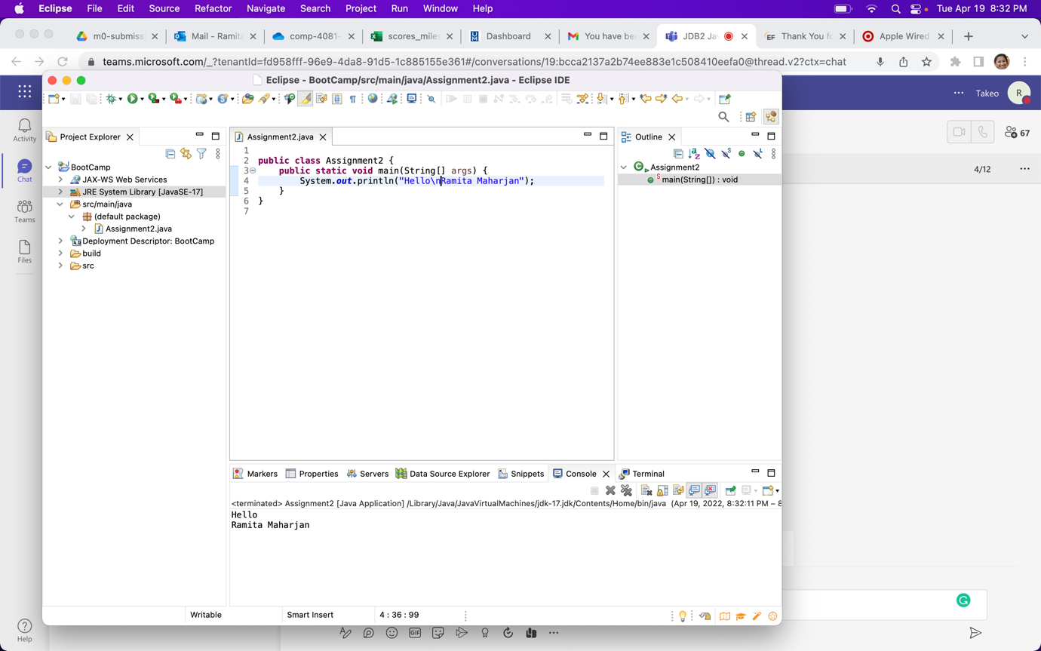

2. Write a Java program to print the sum of two numbers. [Go to the editor](https://www.w3resource.com/java-exercises/basic/index.php#editorr)  
Test Data:  
74 + 36  
Expected Output :  
110

Ans. public class Exercise2 {

public static void main(String[] args) {

System.out.println(24+26);

}

}

import java.util.Scanner;

public class Main {

public static void main(String[] args)

{

Scanner input = new Scanner (System.in);

System.out.print("Input the first number: ");

int num1 = input.nextInt();

System.out.print("Input the second number: ");

int num2 = input.nextInt();

int sum = num1 + num2;

System.out.println();

System.out.println("Sum: "+sum);

}

}

import java.util.Scanner;

public class Main {

public static void main(String[] args)

{

Scanner input = new Scanner (System.in);

System.out.print("Input your first name: ");

String fname = input.next();

System.out.print("Input your last name: ");

String lname = input.next();

System.out.println();

System.out.println("Hello \n"+fname+" "+lname);

}

}

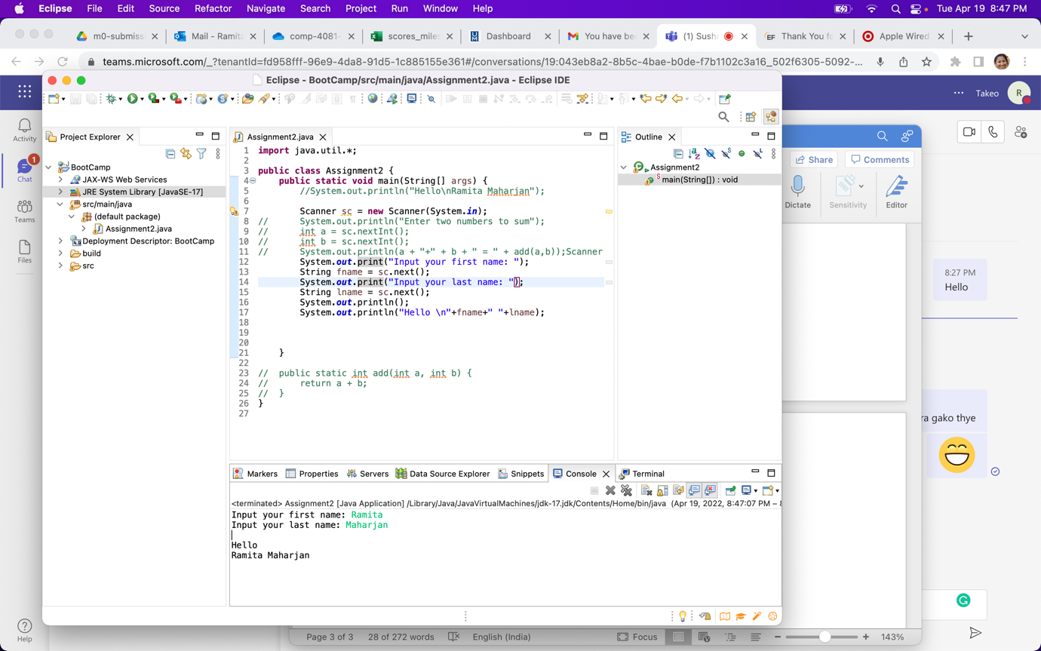

import java.util.Scanner;

public class Main {

public static void main(String[] args)

{

Scanner input = new Scanner (System.in);

System.out.print("Input the first number: ");

int a = input.nextInt();

System.out.print("Input the second number: ");

int b = input.nextInt();

int d = (a/b);

System.out.println();

System.out.println("The division of a and b is:" +d);

}

}

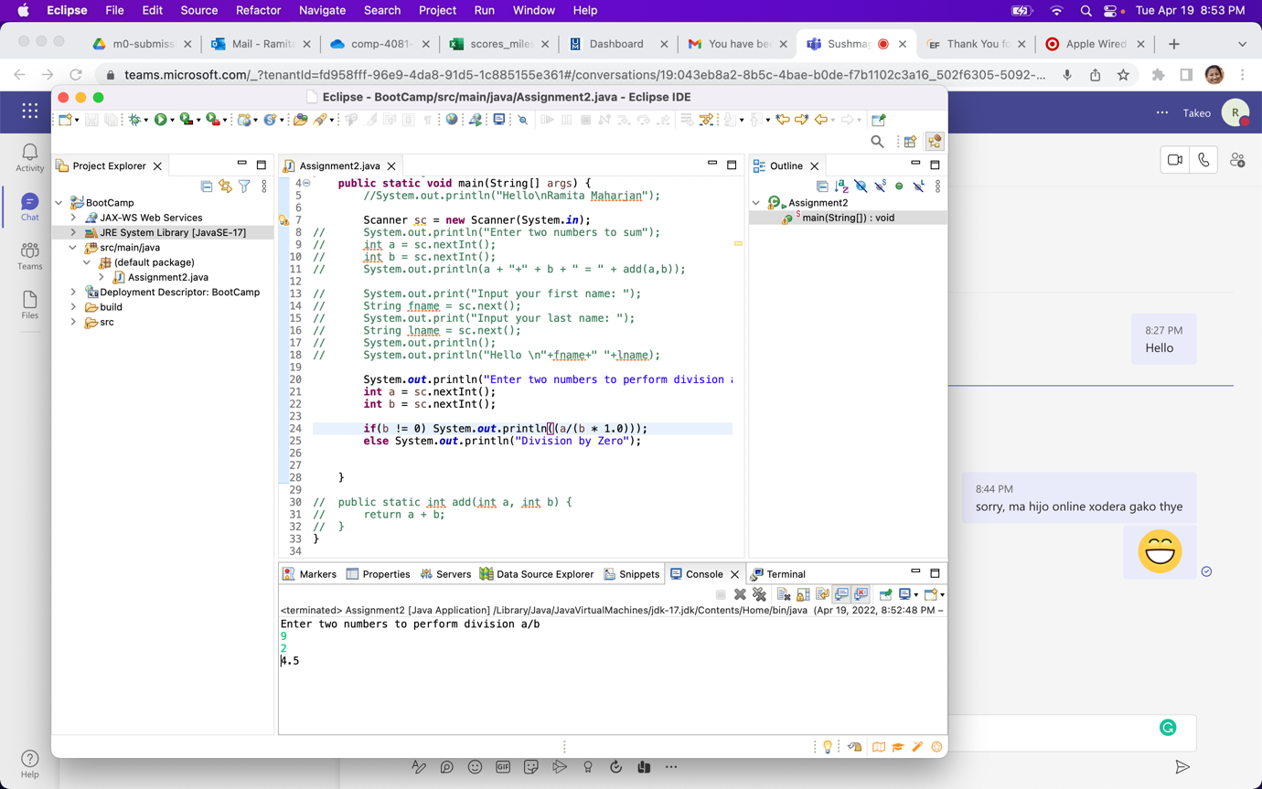

**4.** Write a Java program to print the result of the following operations. [Go to the editor](https://www.w3resource.com/java-exercises/basic/index.php#editorr)  
Test Data:  
a. -5 + 8 * 6  
b. (55+9) % 9  
c. 20 + -3*5 / 8  
d. 5 + 15 / 3 * 2 - 8 % 3  
Expected Output :  
43  
1  
19  
13

